eCMS MANUAL

TEMPORARY IMPORT/EXPORT REQUEST TIER USER MANUAL

Department of Revenue and Customs
Ministry of Finance
Table of Contents
Introduction 1
ECMS FE 1

Introduction
This document shall provide the flow of information related to the use of module Temporary Import/ Export request (TIER) in the eCMS system. TIER is the request to import and export the commodities for a temporary duration.

Front End user can do the following for the TIER:
- Search and Edit TIER Request
- Create TIER Request
- Extend TIER Request
- Cancel TIER Request

ECMS FE
Login to the dashboard
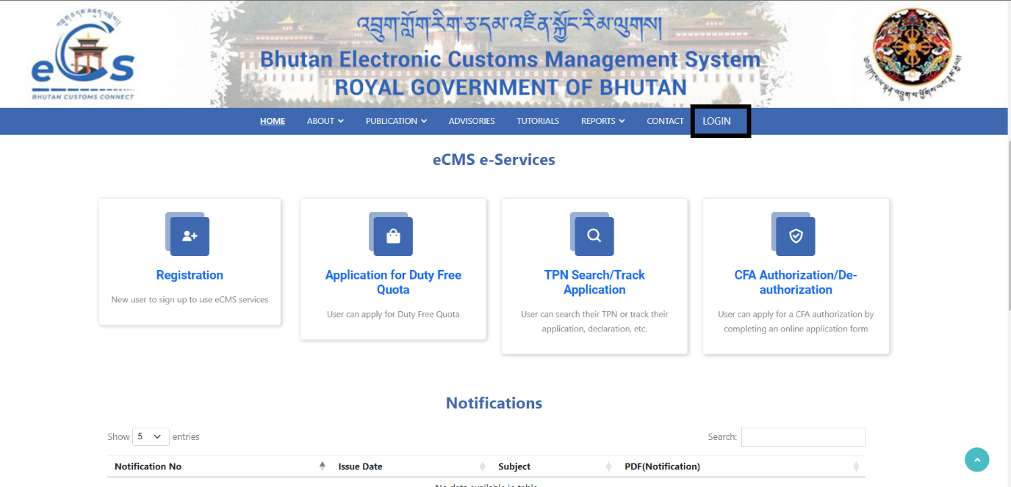

- Search and Edit TIER Request –
  - it will give you the history of the TIER requested by the user.
  - It will give you the draft version of the doc you working on.
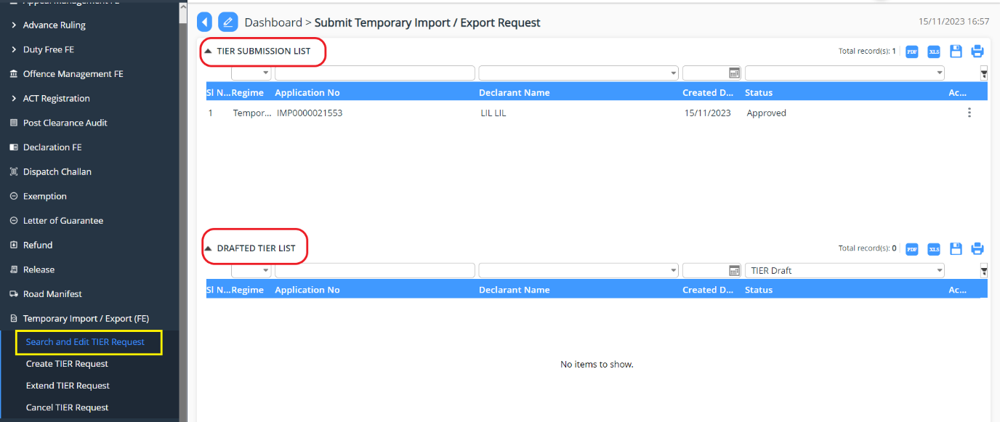

- Create TIER Request
Go to Temporary Import/Export (FE)->> Select Create TIER Request: Start filling in the details as per the requirement.
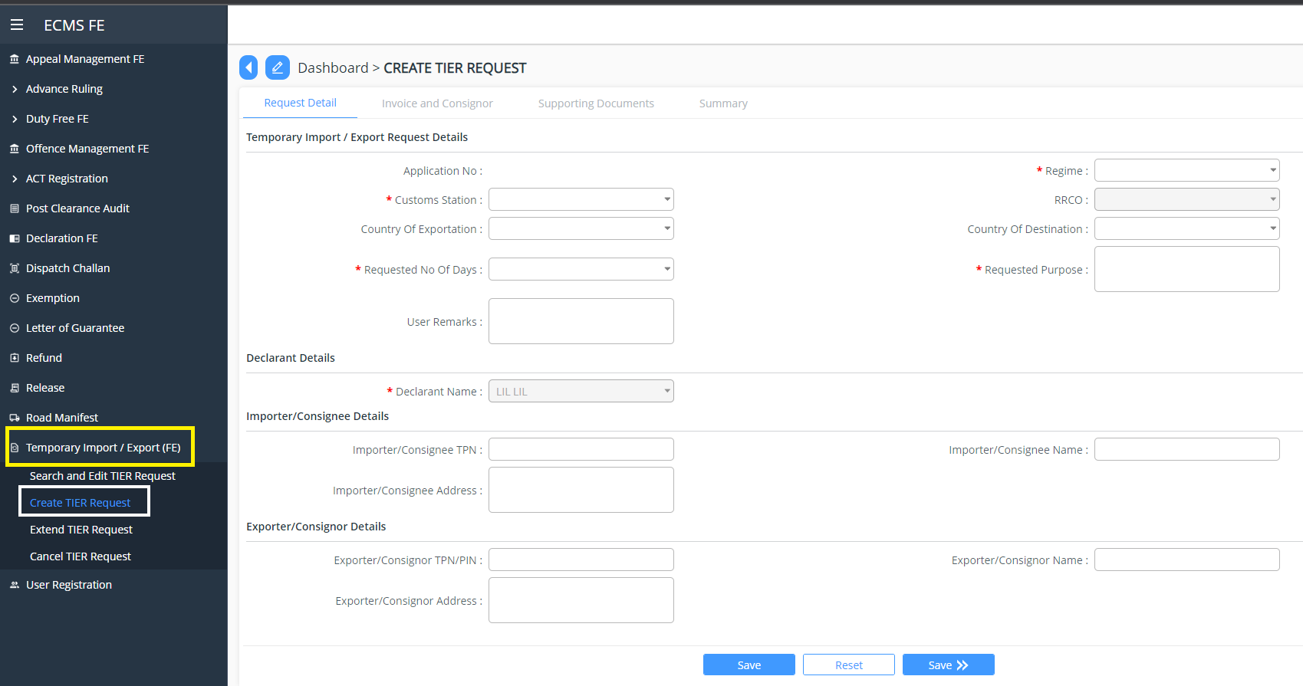

Request Details:
- Select regime:
  - Temporary Import
  - Temporary Export
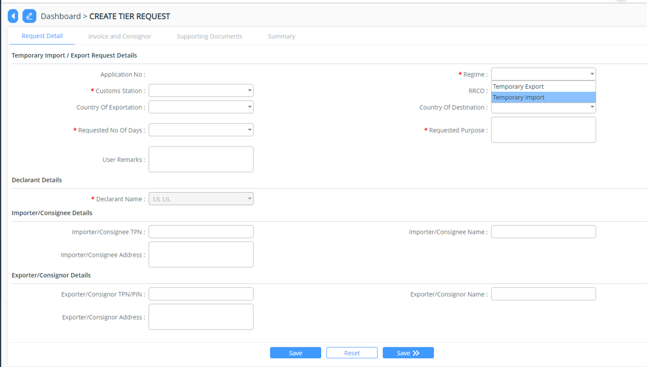

Invoice details next needs to be added:
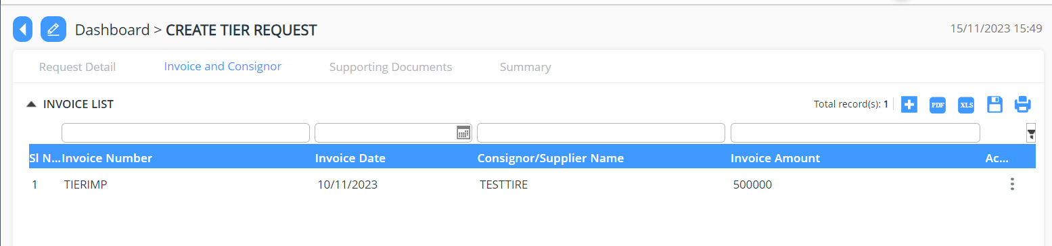

Support document: mandatory document required for the request must be uploaded.

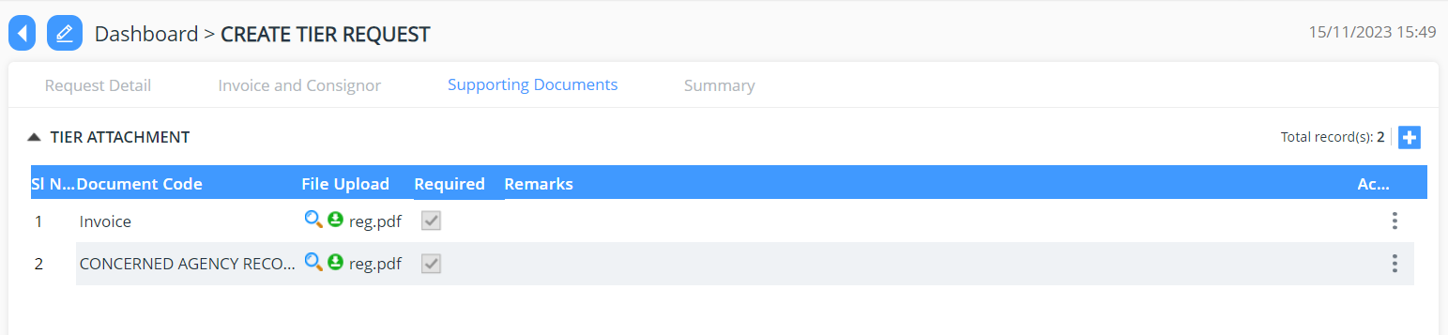

Summary: provide the summary view of the requirement you have added into the different tab
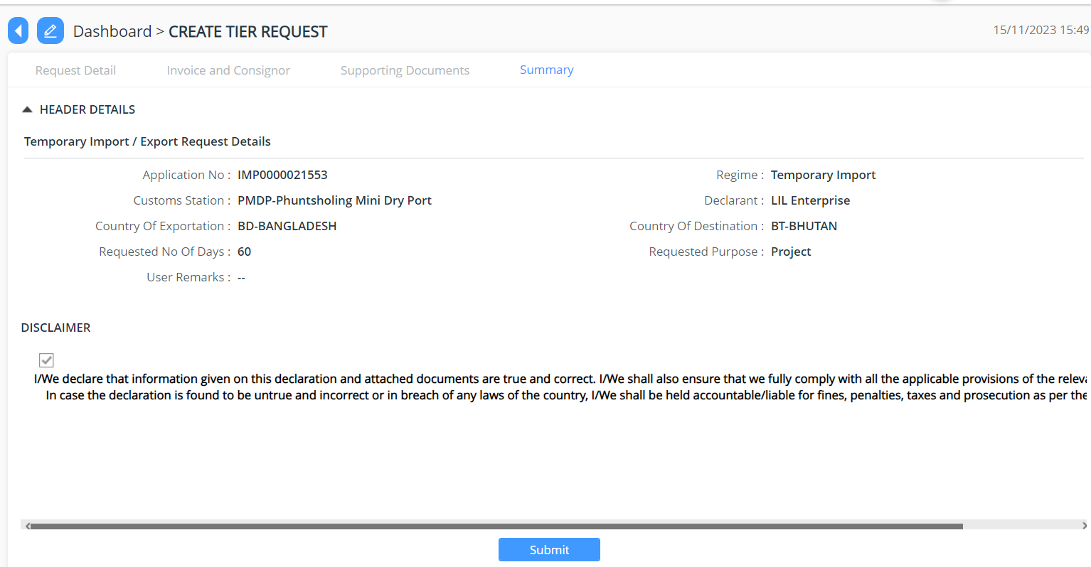

- Extend TIER Request
- Extension of TIER happens when the individual wishes to extend the TIER request application that has been approved.
Go to Temporary Import/Export (FE)->> Select Extend TIER Request
There will be list of submitted request and one can select the application that needs to be extended.

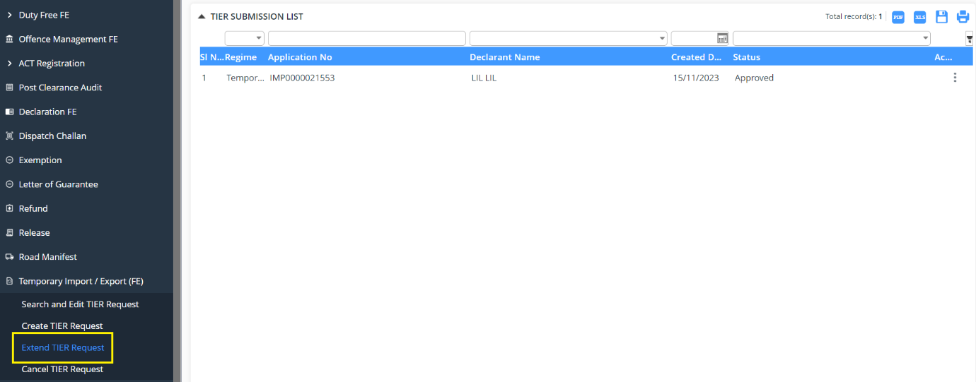

Go to extension detail tab and add in the required extension days then click on Submit

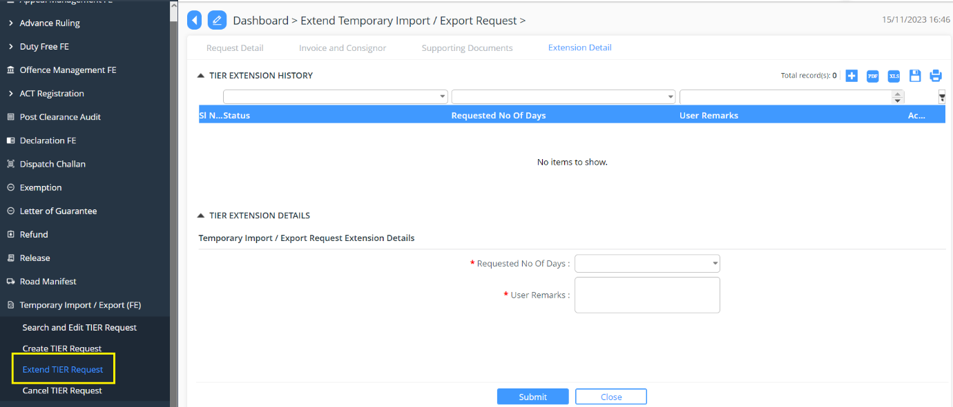

ECMS Cust

